The Sennheiser Group at IBC 2025

Covering all bases in the audio signal chain

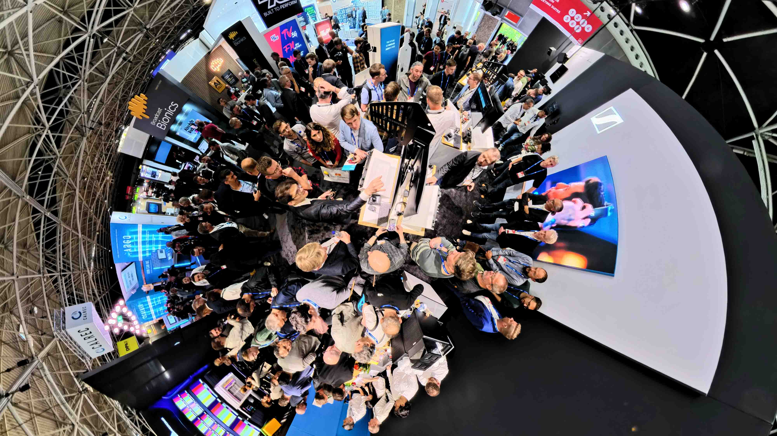

Wedemark/Berlin, 7 August 2025 – At IBC 2025, the Sennheiser Group will be showcasing its audio solutions for the creation of professional media content and entertainment experiences. Visitors to stand 8D50 in the Audio Hall will be able to see and experience the group’s audio highlights, encompassing solutions for recording, monitoring and playout, including some new launches from Neumann.

The best from past and present
Celebrating the company’s 80th anniversary, the Sennheiser showcase plays with the fascinating contrast between historical images from Sennheiser’s rich broadcast past and the latest advances in audio technology, including the wideband Spectera wireless ecosystem and narrowband EW-DX systems.

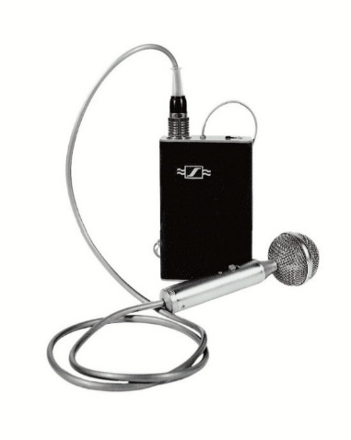 | 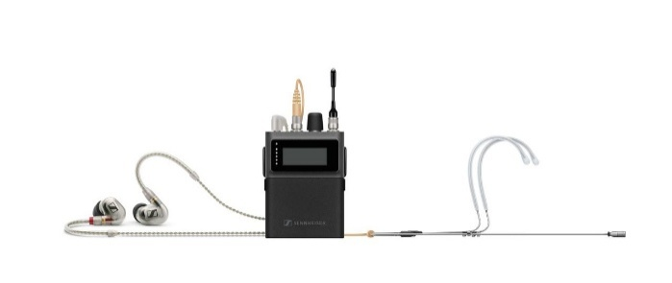
From past to present: Sennheiser mikroport transmitter from the 1950s and today’s Spectera bidirectional SEK bodypack

MKH 8018 stereo shotgun completes the MKH 8000 series
Following on from the Sennheiser MKH 8030 figure-of-eight microphone, broadcasters and filmmakers can now discover the latest addition to Sennheiser’s MKH series of RF condenser microphones, the MKH 8018 stereo shotgun microphone. Providing flexibility for audio engineers, the climate-proof, rugged shotgun microphone features three switchable stereo modes: MS stereo, for step-free adjustment of spatial imaging, and wide or narrow XY stereo, which are premixed in the MKH 8018 with settings that were fine-tuned and verified in multiple user field tests. An integrated -10dB pad, broadcast-friendly frequency response of 40 – 20,000 Hz, and a compact, lightweight aluminium housing round off this exceptional pro microphone.

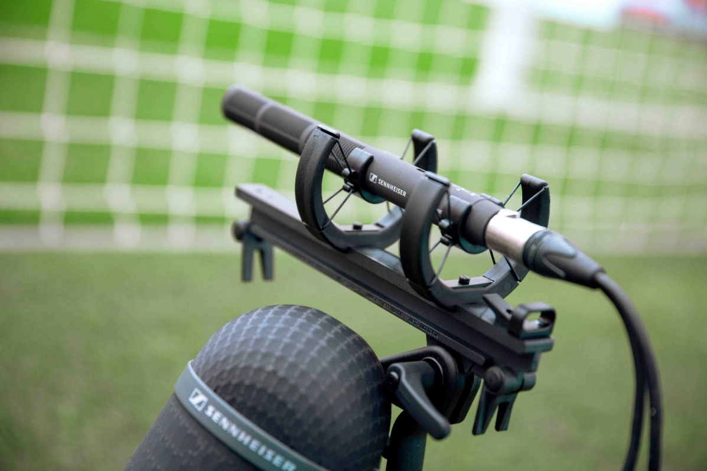
The Sennheiser MKH 8018 stereo shotgun microphone with three selectable stereo modes

SoundBase, the world’s first brand-neutral RF planning tool
The Sennheiser team are delighted to welcome SoundBase as a guest, and will be demoing their app, which is the world’s first universal wireless audio management software.

To coordinate a production’s wireless mics and monitors today, RF managers and monitor engineers still need to handle multiple software tools to set up the wireless brand by brand.

SoundBase addresses these fragmented workflow challenges that have long plagued the industry.

Developed by audio veterans Matt Dale and Donny Kuser, the app integrates with equipment from all major manufacturers, eliminating the need to switch between multiple applications, particularly during critical production moments. It streamlines wireless coordination, centralizes communication, and enables seamless remote collaboration. https://soundbase.app/

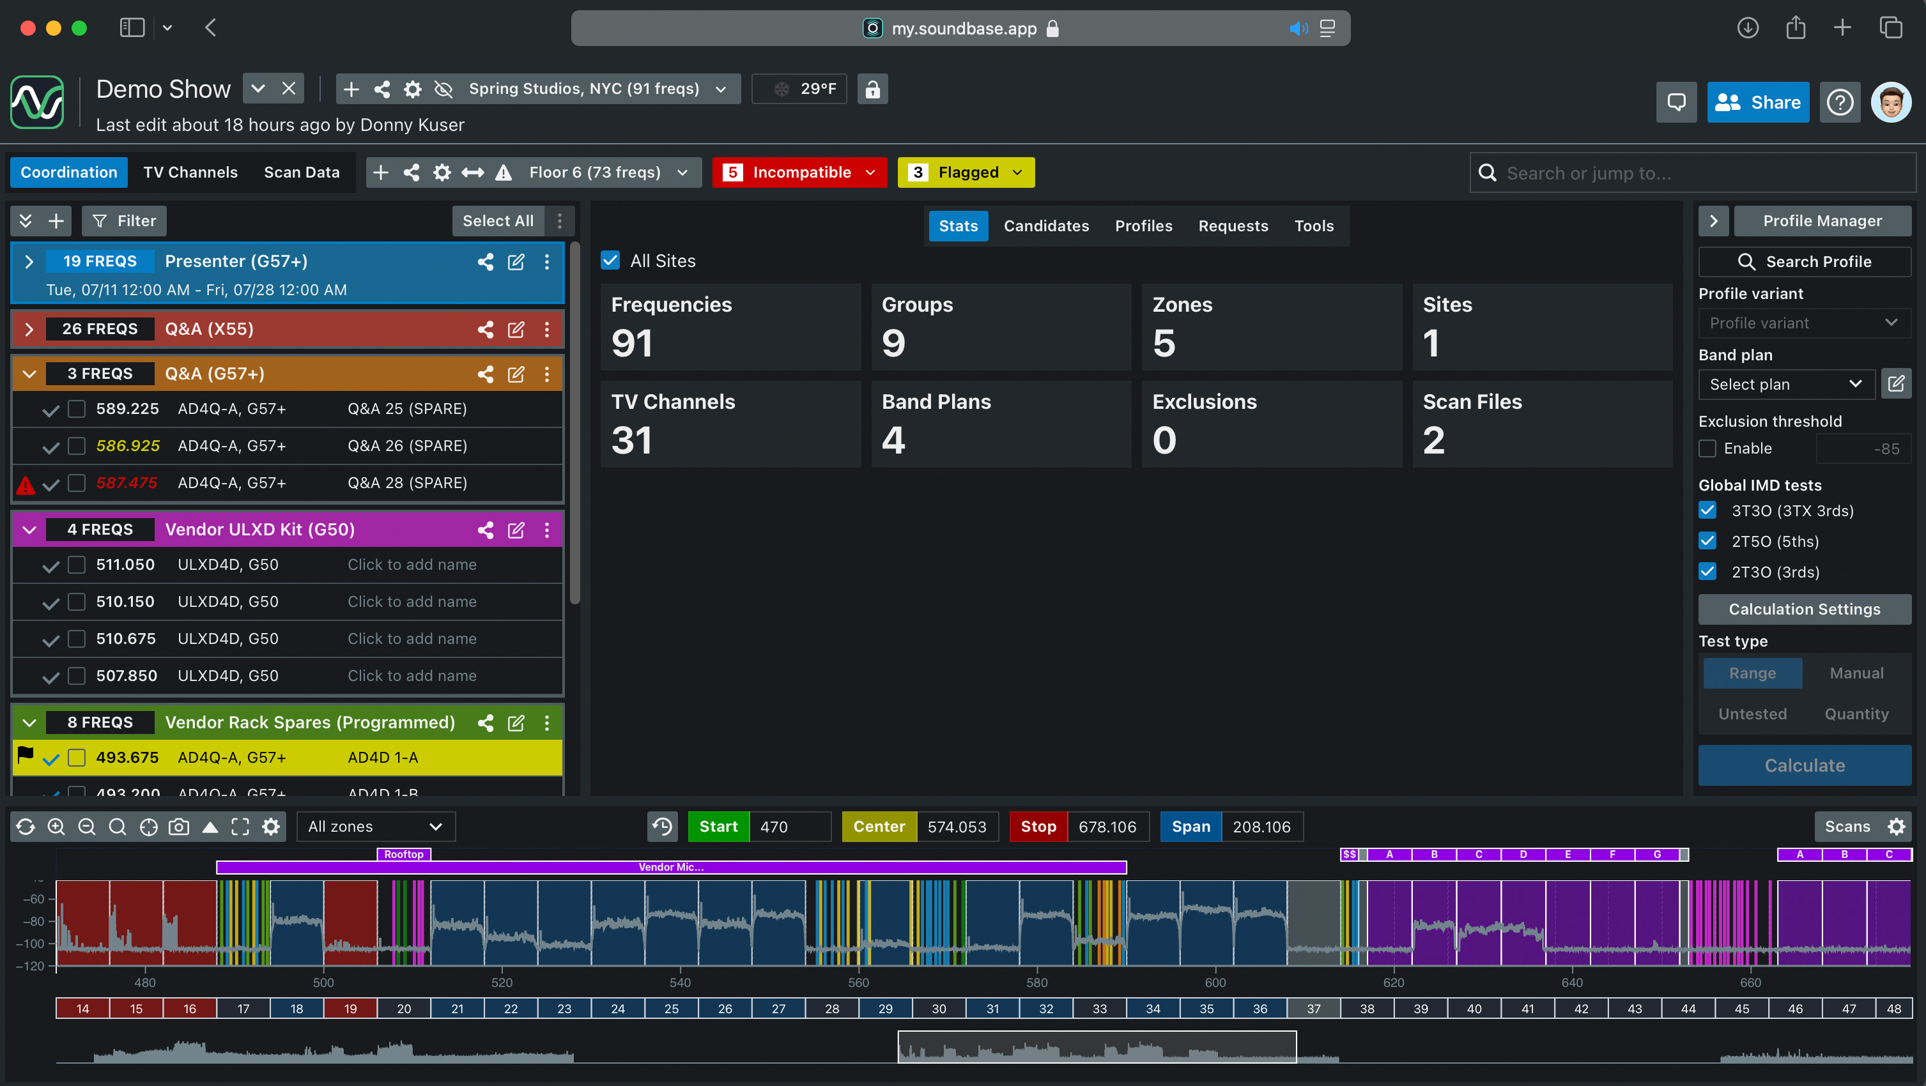
SoundBase works with wireless systems from every major manufacturer, providing the audio team with a single, time-saving and efficient workflow

Spectera and SoundBase demonstrations
The SoundBase RF planning tool and Spectera, the world’s first bidirectional wideband wireless ecosystem, will be demoed on the Friday, Saturday and Sunday of the show:
- Spectera demo sessions at 11 a.m. and 2 p.m.
- SoundBase demo sessions at 12 noon and 3 p.m.
Visitors who cannot make it to these slots are welcome to join us for ad hoc presentations at stand 8D50.

Networked Neumann and Merging areas
Neumann will showcase its range of studio monitors in a dedicated studio area featuring a 7.1.4 immersive setup. This includes a brand-new subwoofer with multichannel bass management – to be launched at IBC!

Of course, Neumann will also present a variety of its microphones, including the BCM 104 broadcast mic, capsule heads for wireless systems, MCM Miniature Clip Mics, TLM 102 and TLM 107 as well as a selection of its legendary classics, such as the U 87 Ai, U 67, U 47 fet and M 49 V. And you can also meet another legend, the KU 100 binaural head, now in its 34th year and still the easiest way to produce stunningly realistic immersive audio.

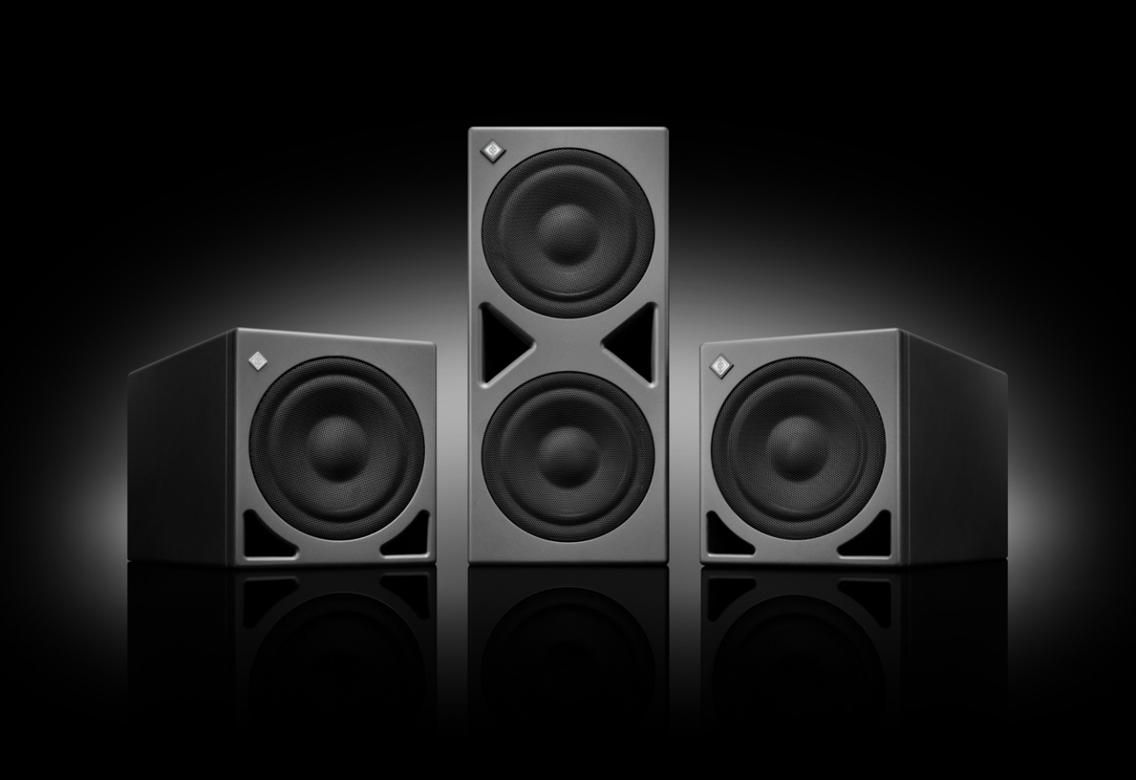
Something’s coming from deep below…

As part of the immersive studio/OB van area, Merging Technologies – part of Neumann – will showcase the Pyramix 15 DAW, along with the Hapi Mk III modular audio interface. The desktop audio interfaces Merging Anubis and Neumann MT 48 will also be demonstrated, including recently added OSC control capabilities, allowing remote controlling fader moves and other parameter changes via third-party hardware controllers.

Running in a Ravenna AES 67 network, the studio area links to a second demo area of the Neumann/Merging showcase, which is on a Dante AES 67 network. Here, visitors will be able to experience Neumann’s new RIME plug-in, enabling immersive monitoring using NDH 20 and NDH 30 headphones.

Also demonstrated will be Merging’s state-of-the-art Ovation playout system and show sequencer. Version 11, which was recently released, introduces a bold new design with a refined dark-mode interface and streamlined usability. The updated, fully customizable mixer, panner, and renderer allows users to tailor busses, strips, and aux channels to any workflow – whether for stereo, multizone, or immersive formats.

AMBEO 2-Channel Spatial Audio: Real-Time immersive rendering for stereo broadcasting
Delivering immersive audio experiences without segmenting the audience or complicating the signal chain remains a key challenge for live broadcasters. The AMBEO 2-Channel Spatial Audio live renderer solves this issue by enabling real-time rendering of immersive content into a stereo-compatible AMBEO format. The two-channel output retains spatial depth and localisation cues, optimised for playback on any stereo system, and improves voice intelligibility — no additional decoding or hardware required.

Powered by proprietary immersive audio algorithms, AMBEO generates a hardware-agnostic, downstream-compatible signal that preserves the creative intent and immersive quality of the original mix. Broadcasters and streaming providers can maintain the stereo delivery path while offering a significantly enhanced listening experience.

Visitors can experience this technology embedded on a Merging ANUBIS device, showcasing low-latency performance and seamless integration into existing live production workflows.

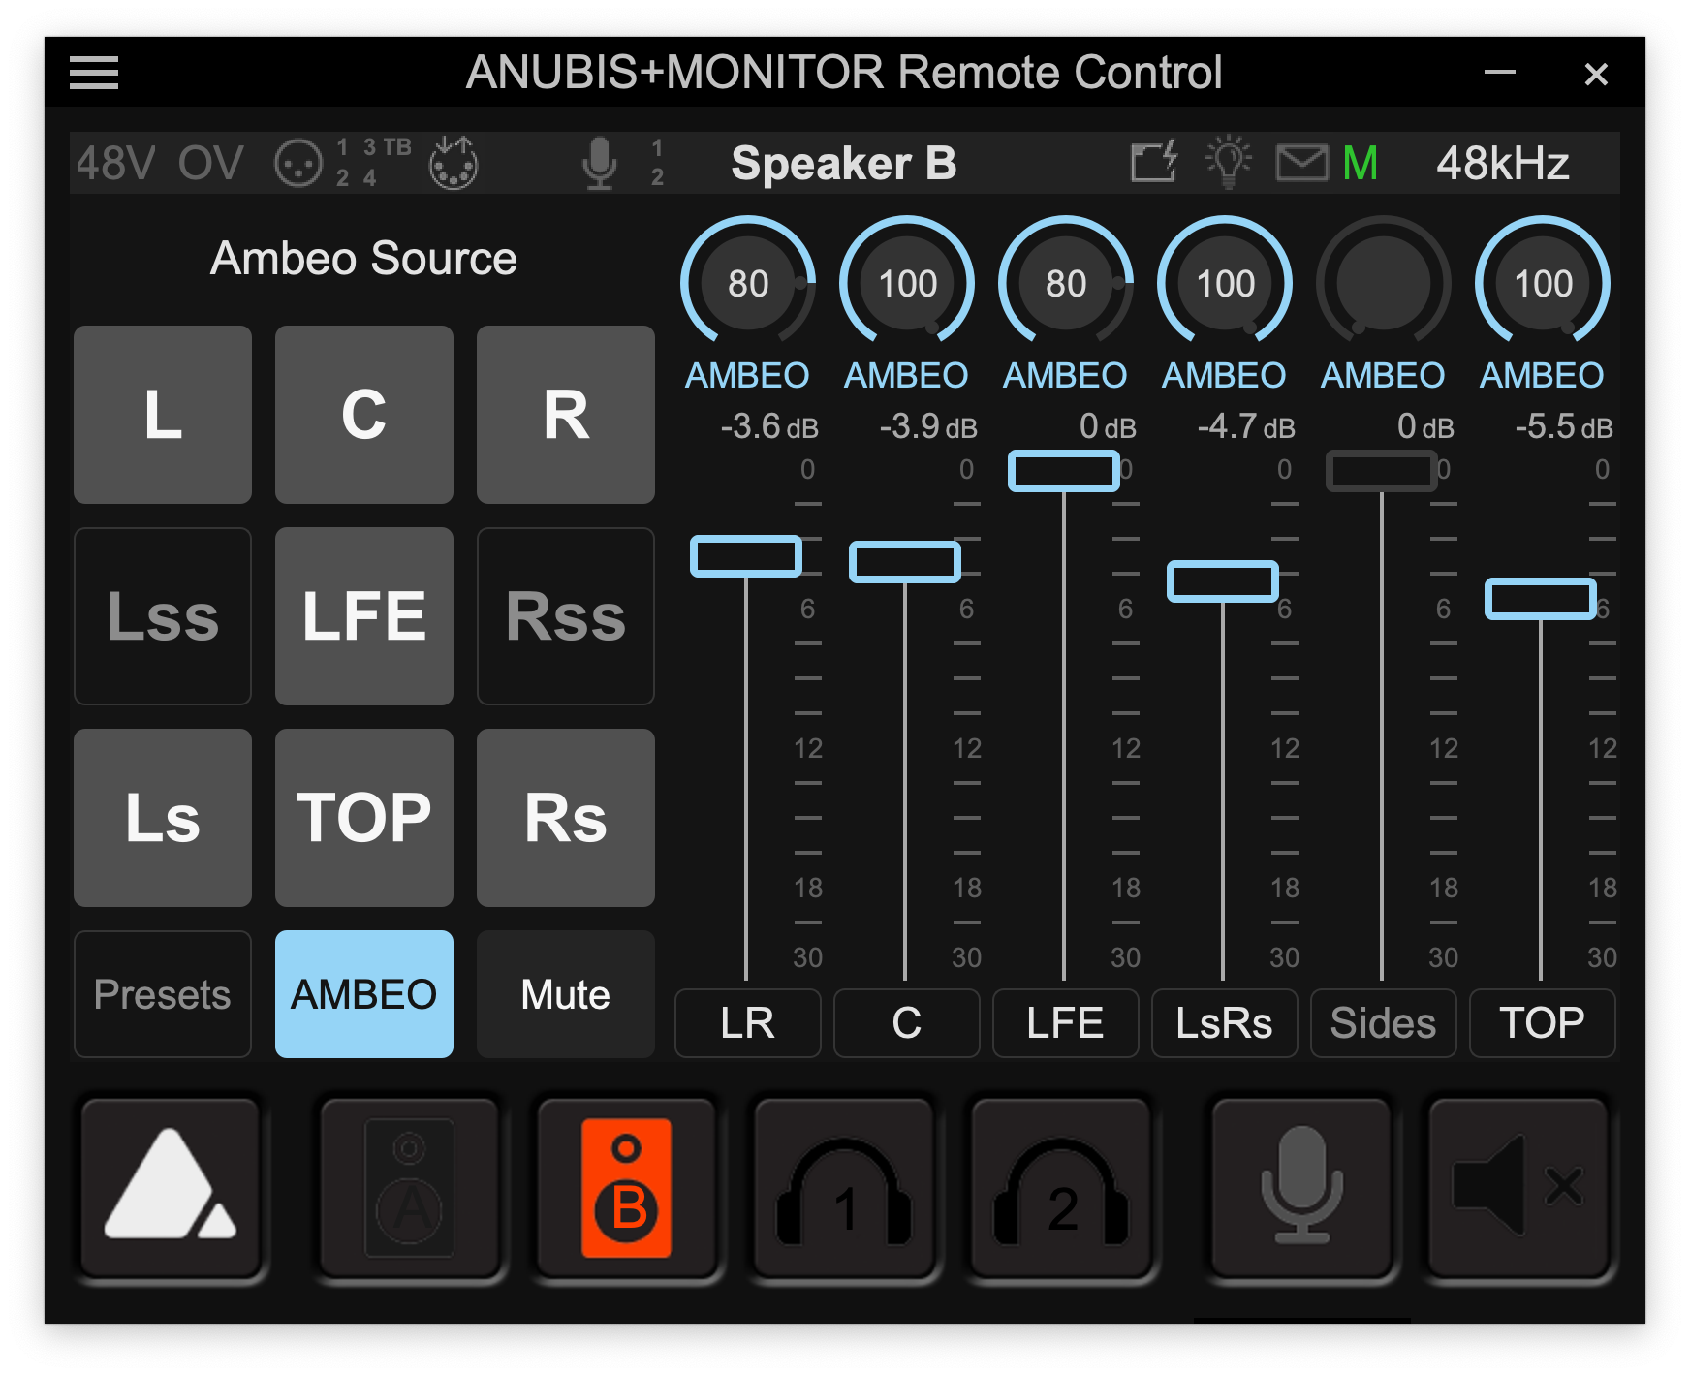
The AMBEO 2-Channel Spatial Audio live renderer unlocks investments into surround and immersive content for all viewers. Pictured is the renderer interface for finetuning the spatially enhanced two-channel mix, controlled via the standard Anubis remote control software

About the Sennheiser Group
We live and breathe audio. We are driven by the passion to create audio solutions that make a difference. In 2025, the Sennheiser Group celebrates its 80th anniversary. Since 1945, we’ve stood for building the future of audio and bringing remarkable sound experiences to our customers.

Today, the Sennheiser Group is one of the leading manufacturers in the field of professional audio technology. With our brands Sennheiser, Neumann, AMBEO and Merging, we offer a comprehensive range of solutions that is fully tailored to the needs of our customers. As an independent family-owned company, in our third generation we are led by co-CEOs Dr. Andreas Sennheiser and Daniel Sennheiser. www.sennheiser.com

